Our Address:

The Canary Wharf Clinic
51 Cannon Workshops
Cannon Drive
Adjacent to Hertsmere Road
Canary Wharf
London E14 4AS

Website: www.acupuncturecanarywharf.co.uk

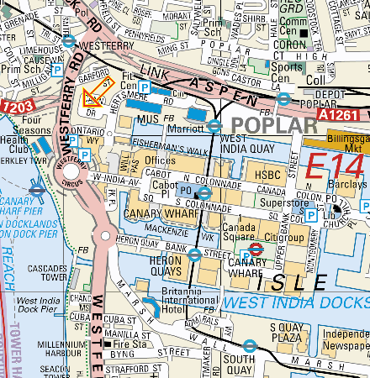

Directions:
We are conveniently located at 51 Cannon Workshops within easy walking distance of Canary Wharf DLR, West India Quay DLR, and Canary Wharf tube station (Jubilee line, zone 2). Free parking is available but please ask your practitioner for a guest permit.

From Canary Wharf DLR: 0.3 miles (approx 5 minutes walk)
Canary Wharf DLR is actually in Canada Square. Follow signs for Cabot Square and exit building. Turn right, go down the stairs and over the foot bridge. Turn left and walk along the dock past the bars and restaurants towards to The Museum of Docklands. You will see the black arch of Cannon Workshops in front of you.
Walk ahead towards the archway. Once directly under the archway, on the right there is a plaque reading ‘units 23-61’. Enter this building. We are unit 51 on the right. Take a seat outside the therapy room and wait for your practitioner. Please keep noise to a minimum. Thank you.
From West India Quay DLR: 0.3 miles (approx 5 minutes walk)
Walk along the dock past the bars and restaurants towards to The Museum of Docklands. You will see the black arch of Cannon Workshops in front of you.
Walk ahead towards the archway. Once directly under the archway, on the right there is a plaque reading ‘units 23-61’. Enter this building. We are unit 51 on the right. Take a seat outside the therapy room and wait for your practitioner. Please keep noise to a minimum. Thank you.
From Canary Wharf Tube Station: 0.6 miles (approx 10 minutes walk)
Leave the west exit of the tube station. The tall escalators will take you up and outside. Turn right and walk ahead with ‘All Bar One’ on your left. Enter the shopping mall of Canada Square and Cabot Place. Follow signs for Cabot Square and exit building. Turn right, go down the stairs and over the foot bridge. Turn left and walk along the dock past the bars and restaurants towards to The Museum of Docklands. You will see the black arch of Cannon Workshops in front of you.
Walk ahead towards the archway. Once directly under the archway, on the right there is a plaque reading ‘units 23-61’. Enter this building. We are unit 51 on the right. Take a seat outside the therapy room and wait for your practitioner. Please keep noise to a minimum. Thank you.

